Ideation Phase
Empathize & Discover

Date | 18th June 2026
Team ID
Project Name | Health Connect
Maximum Marks | 4 Marks

Empathy Map Canvas:
An empathy map is a simple, easy-to-digest visual that captures knowledge about a user’s behaviours and attitudes.

It is a useful tool to helps teams better understand their users.
Creating an effective solution requires understanding the true problem and the person who is experiencing it. The exercise of creating the map helps participants consider things from the user’s perspective along with his or her goals and challenges.
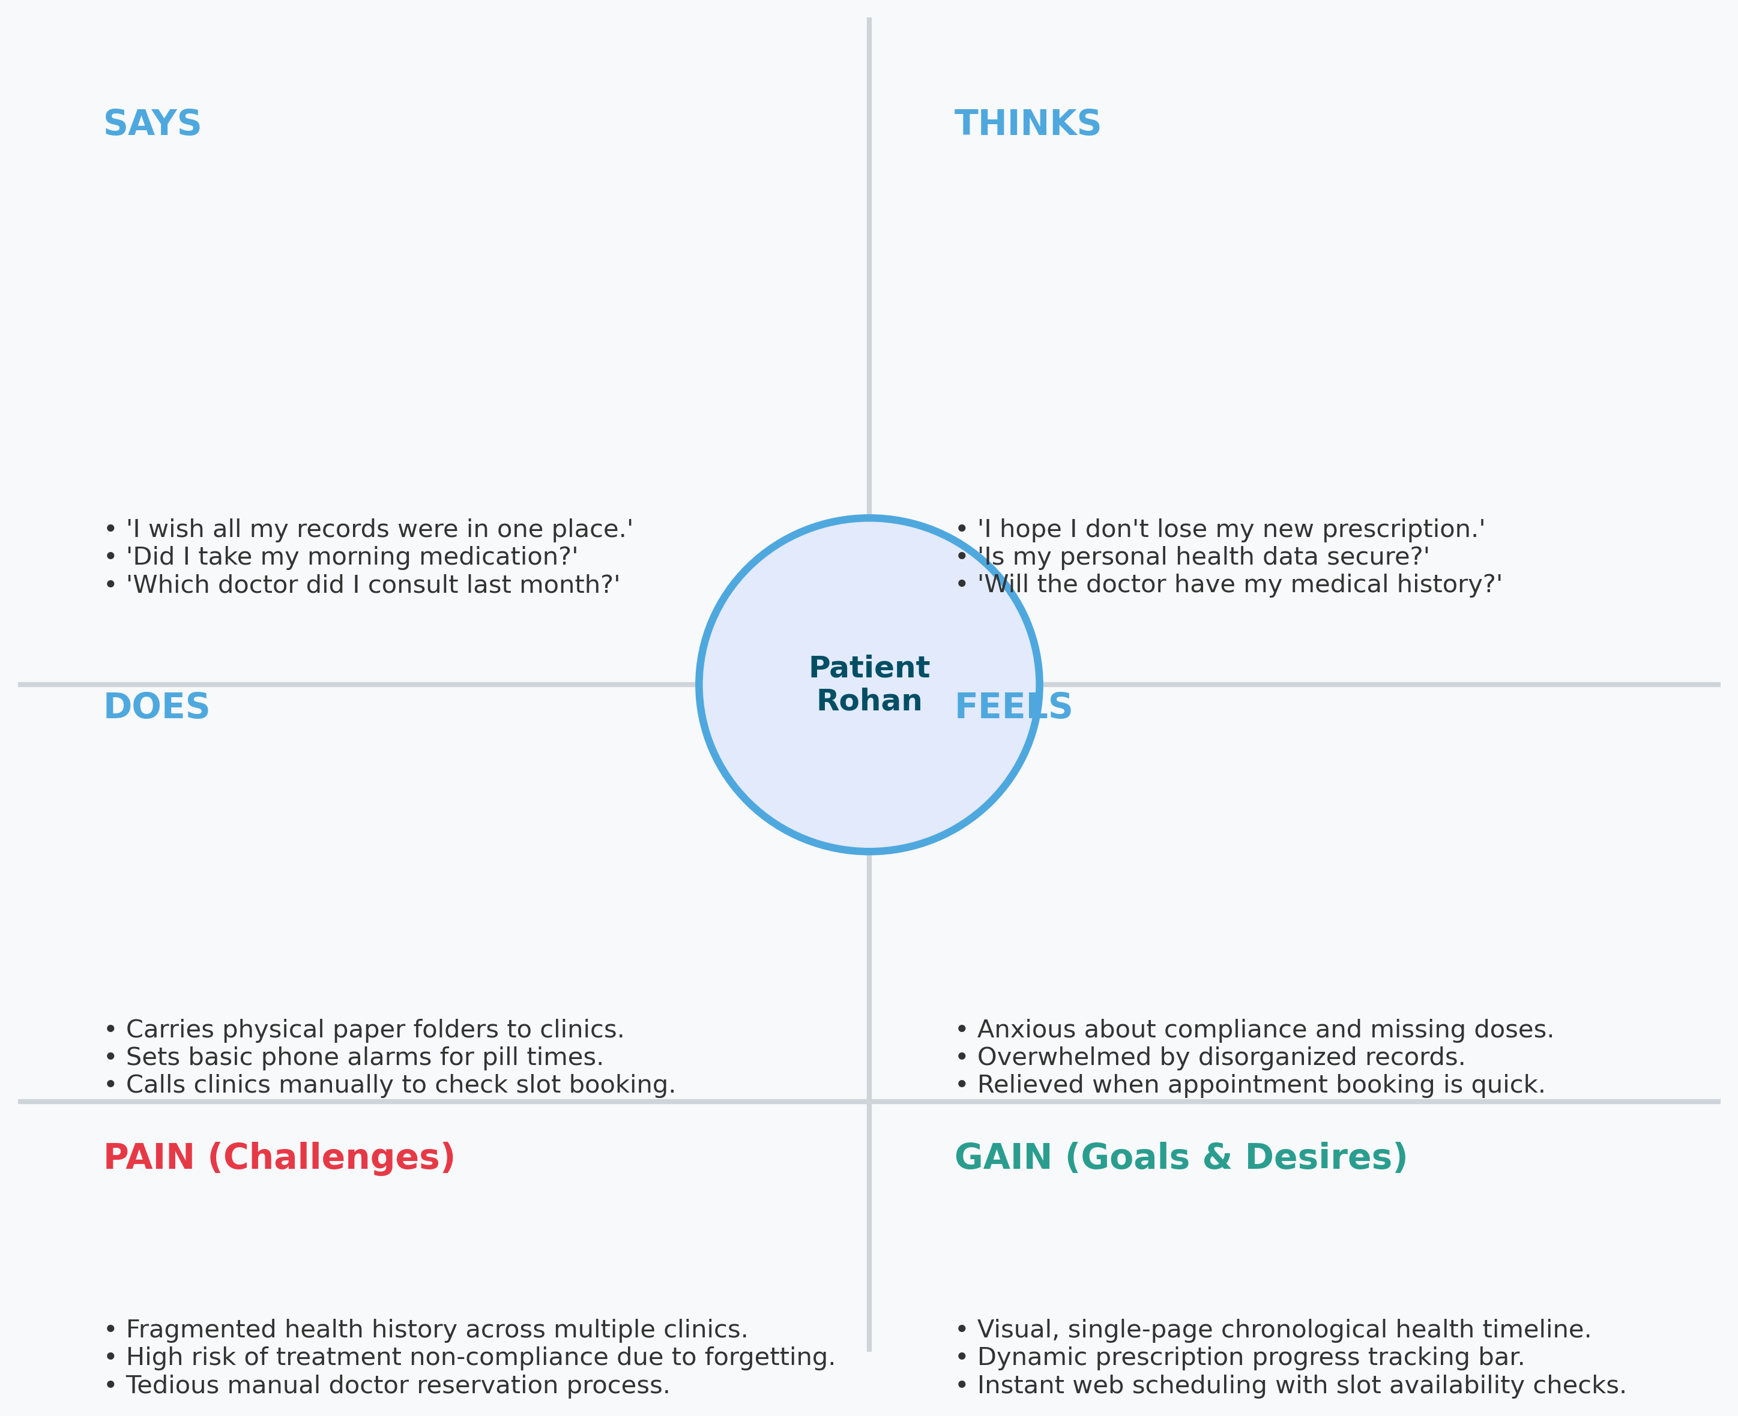


Reference: https://www.mural.co/templates/empathy-map-canvas

Example: Food Ordering & Delivery Application

Empathy Map Canvas Summary - Patient Profile (Rohan Gupta):
• SAYS: 'I wish all my medical files were in one place.' 'Did I take my morning medicine?'
• THINKS: 'I hope I don't lose my new prescription.' 'Will my doctor be able to see my complete medical history?'
• DOES: Sorts paper sheets chronologically; sets phone alarms for pill times; manually books appointments by calling the clinic.
• FEELS: Stressed about health organization; anxious during doctor visits; relieved when medication tracker shows 100% completion.
• PAINS: Scattered records across clinics, compliance errors, difficulty scheduling appointments.
• GAINS: Unified chronological medical timeline, dynamic visual compliance bars, hassle-free slot-based booking.

